**Testing and request log of emall backend system**

Get all products

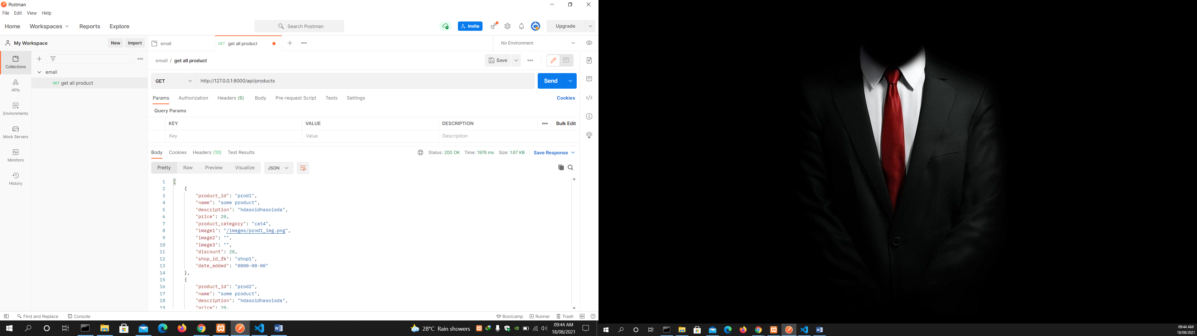

Add a product using post

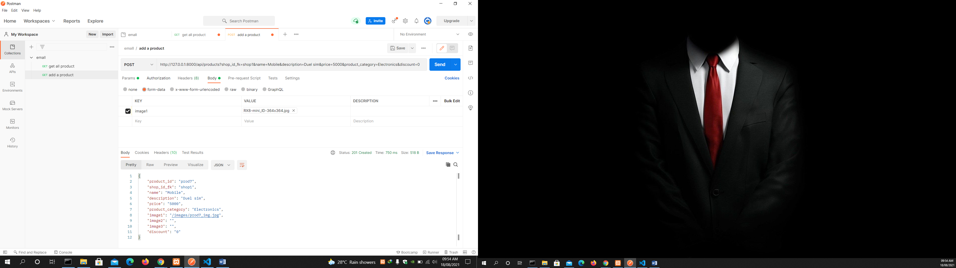

Get all categories

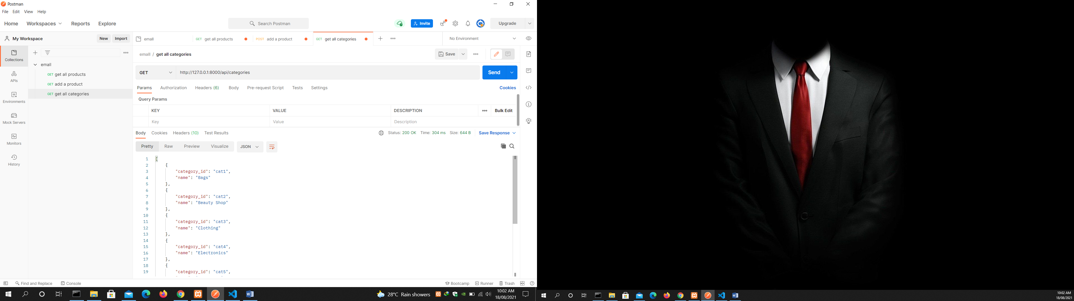

Add a category using post

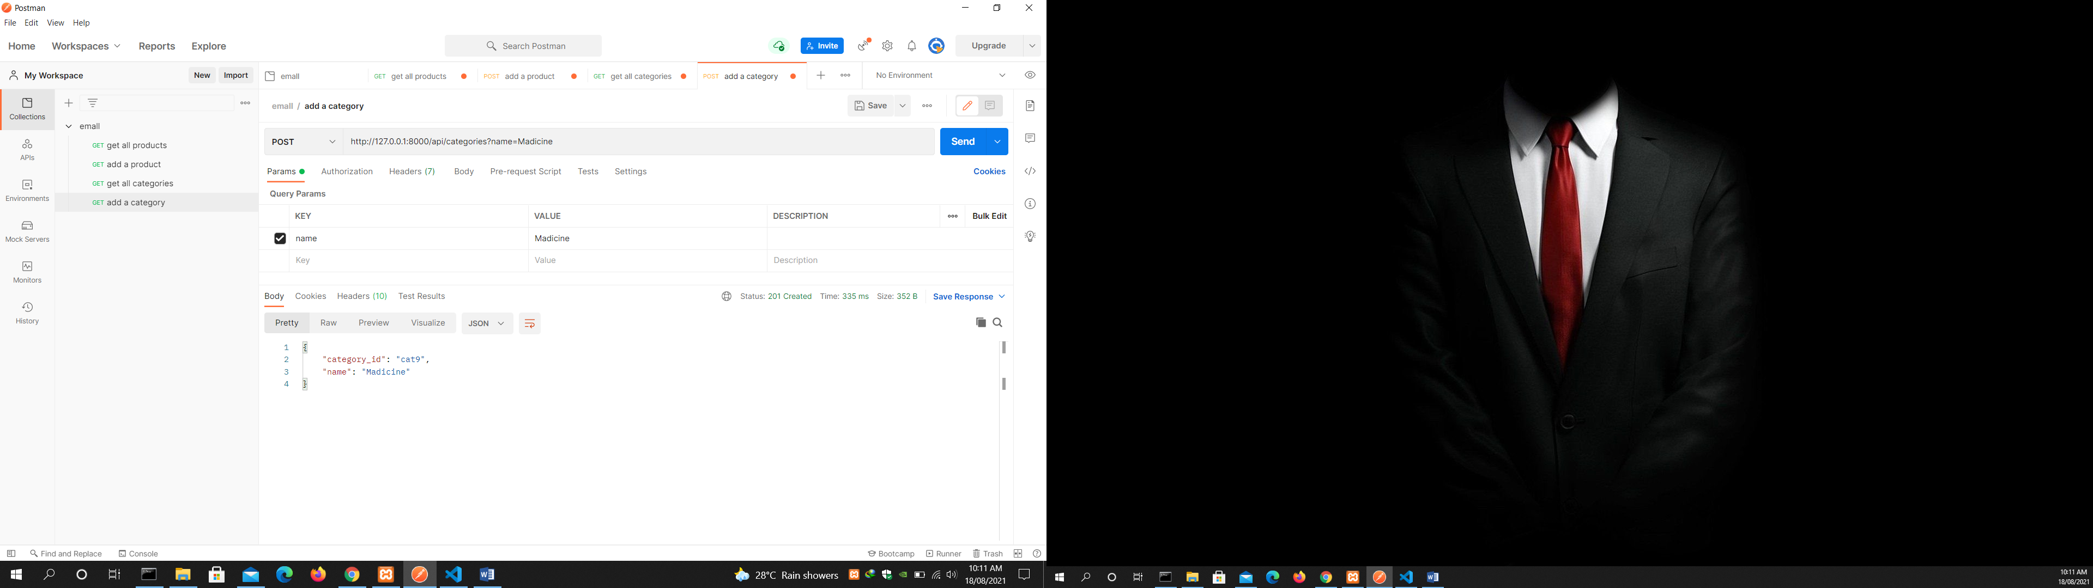

Get all subcategories

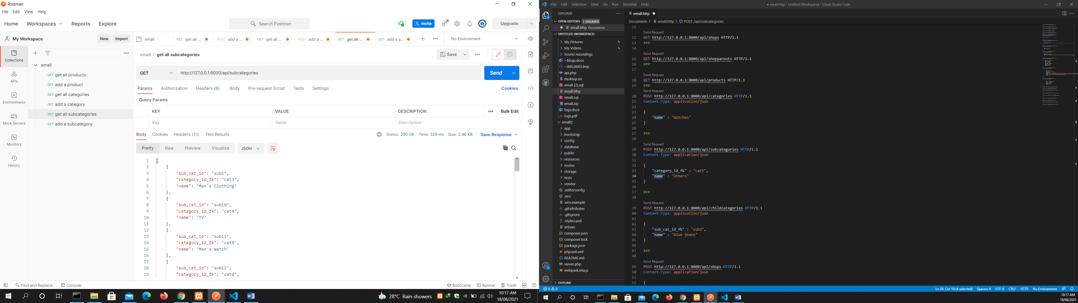

Add a subcategory

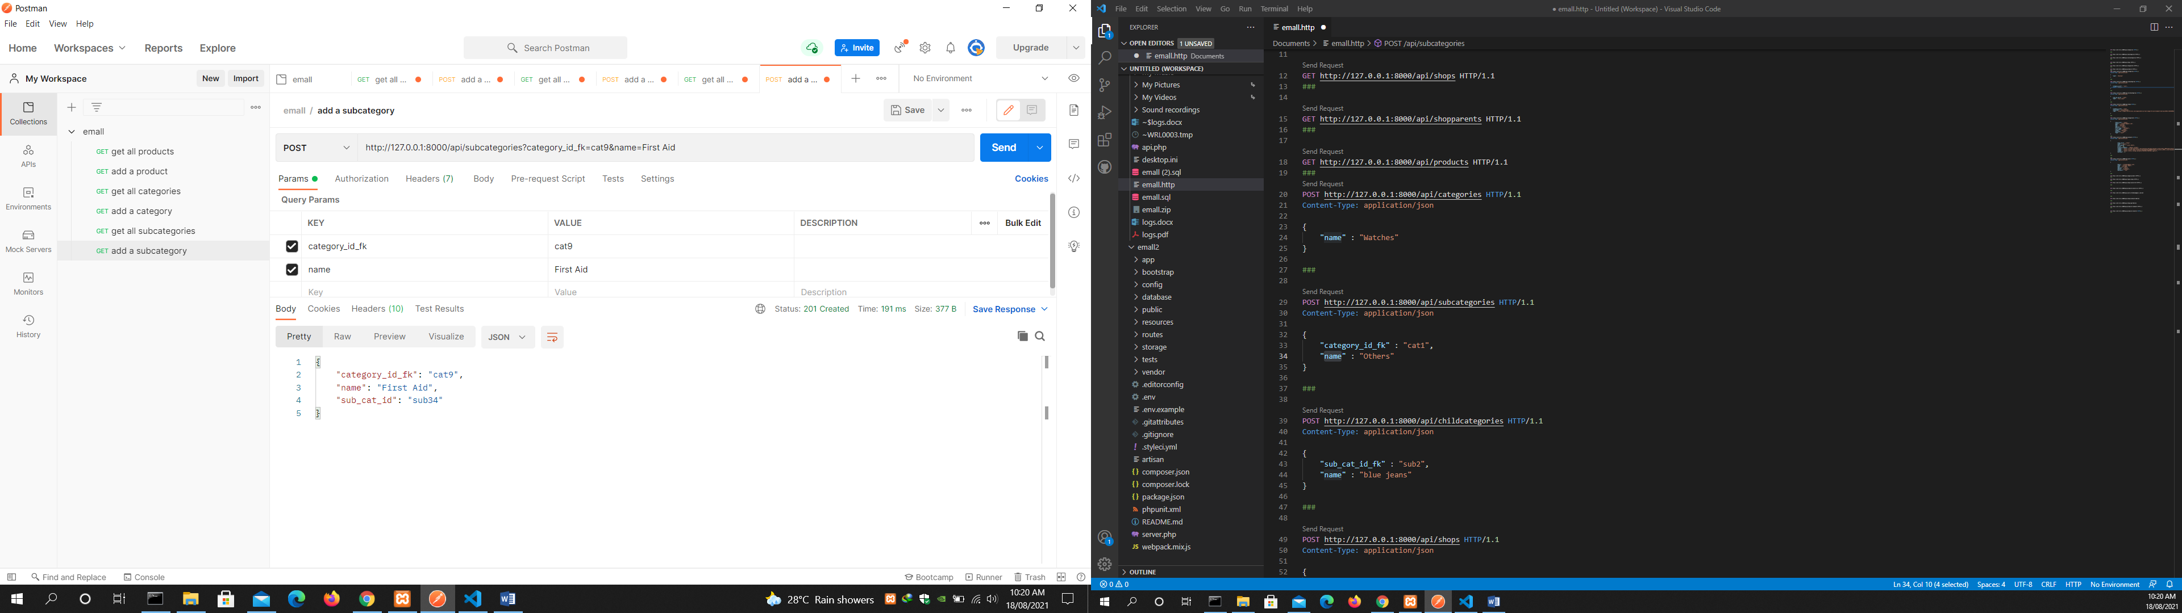

Get all childcategories

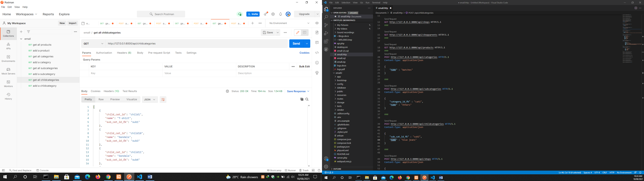

Add a childcategory

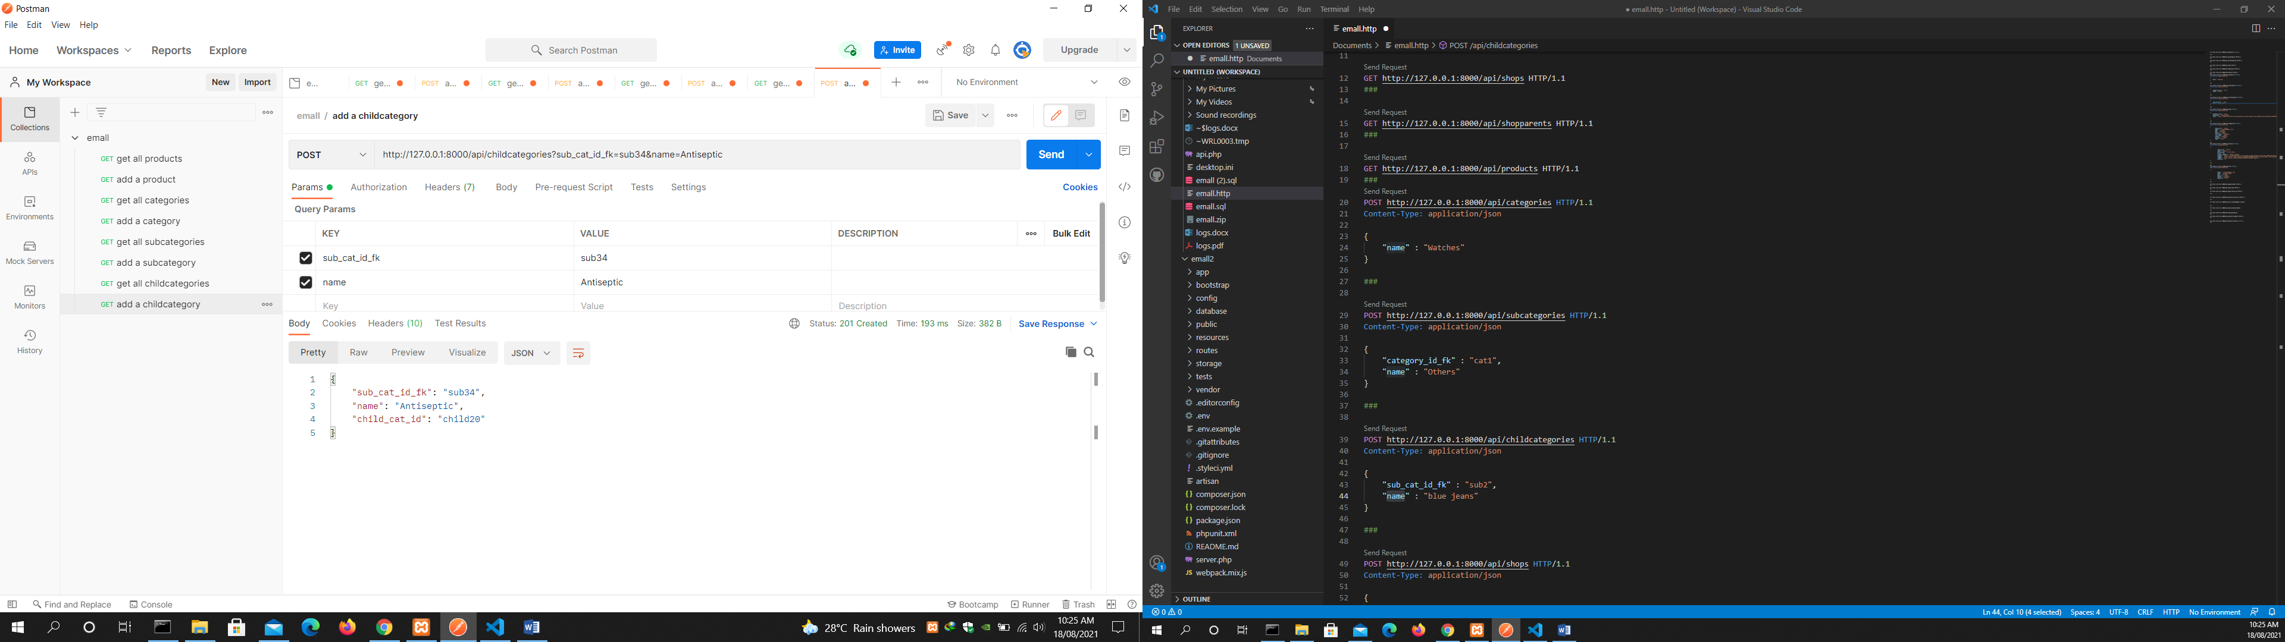

Get all shops

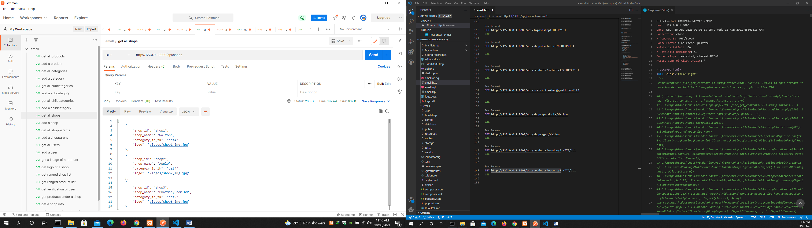

Add a shop

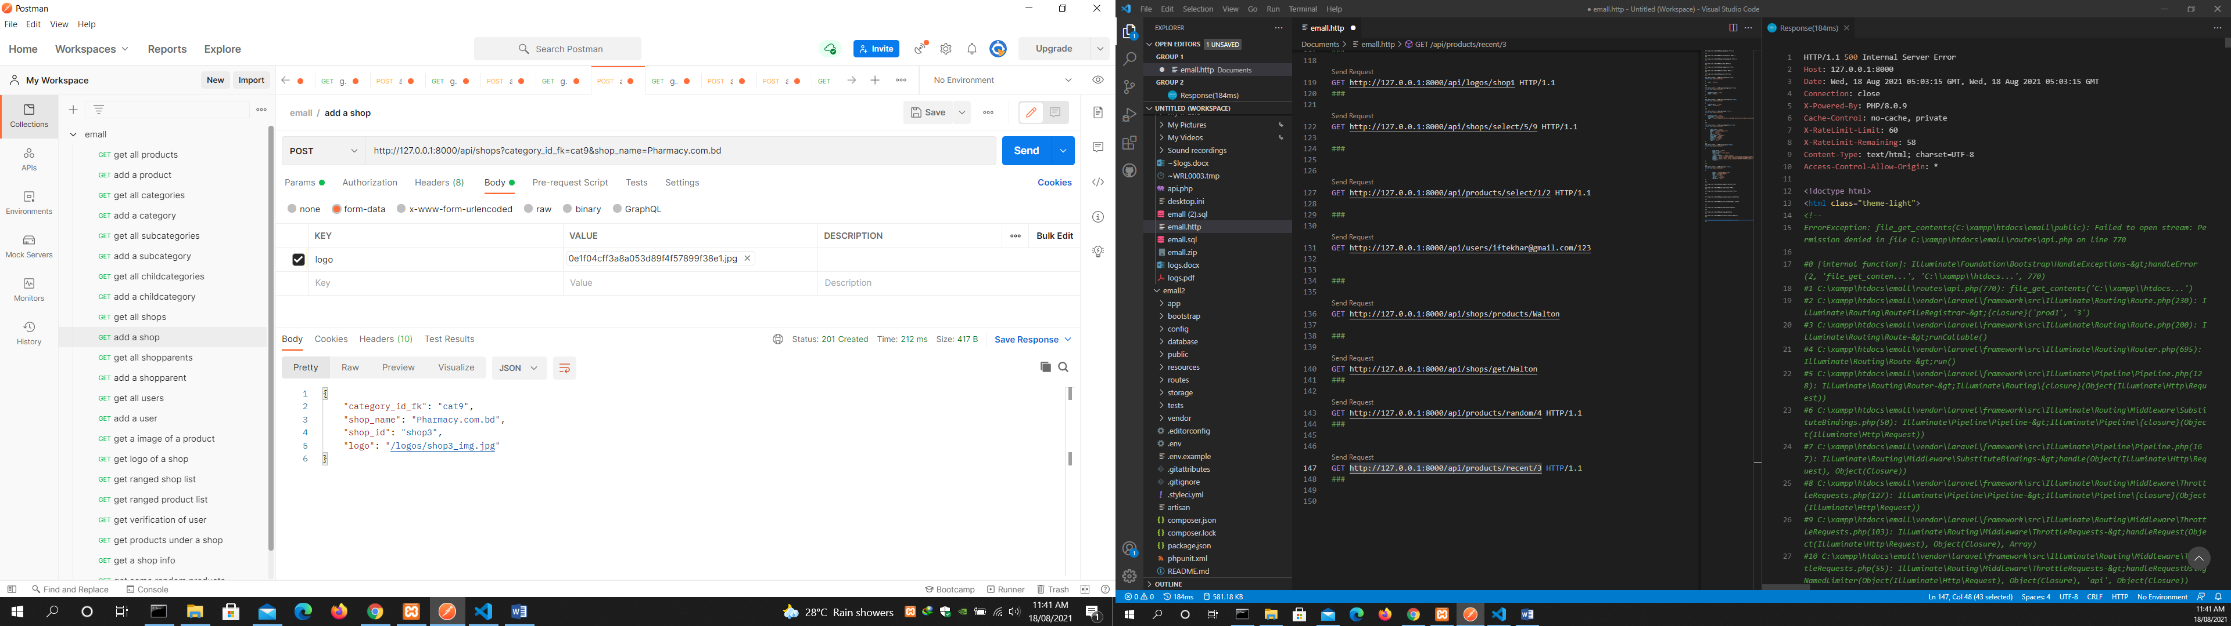

Get all shopparents

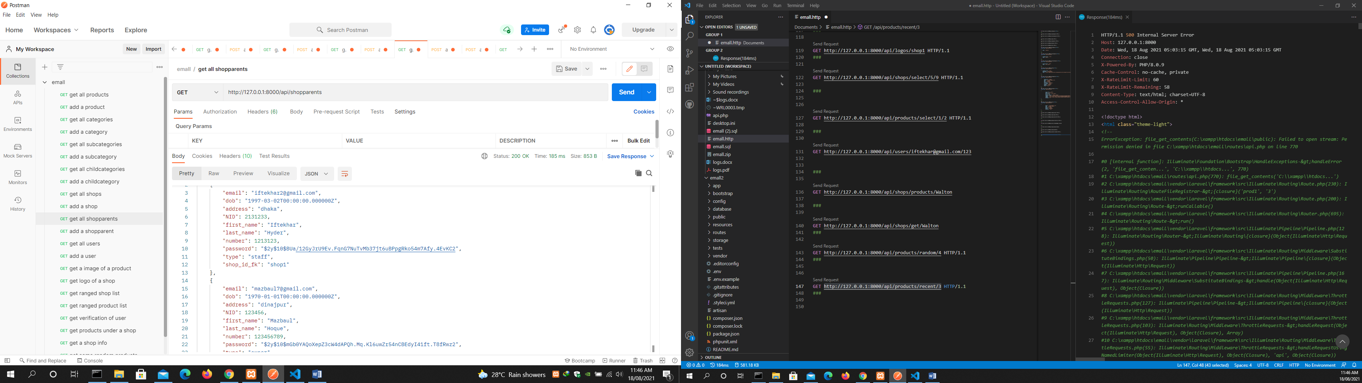

Add a shopparent

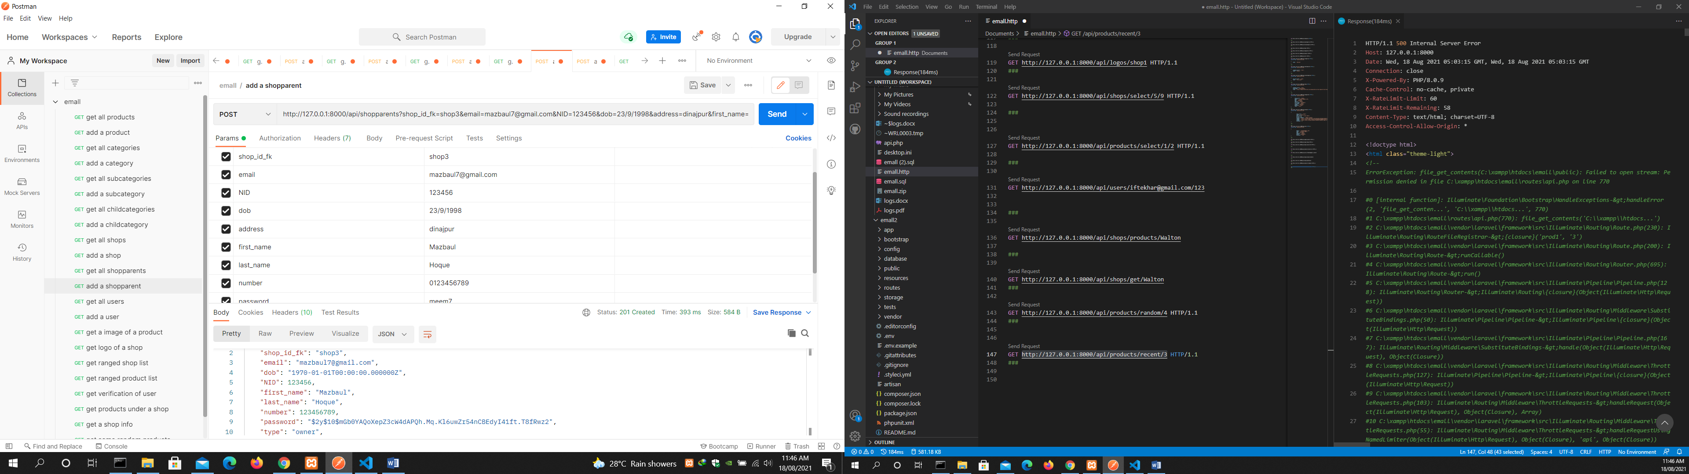

Get all users

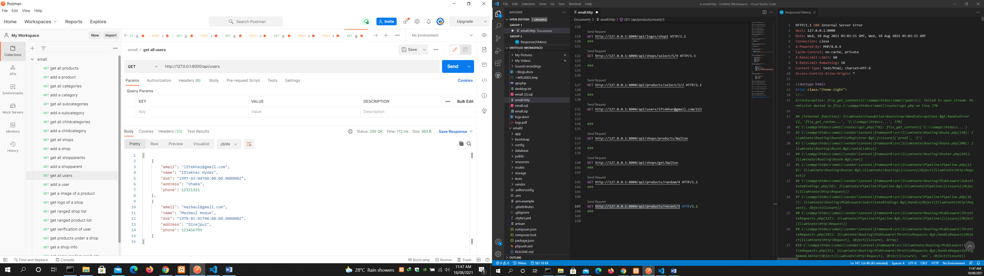

Add a user

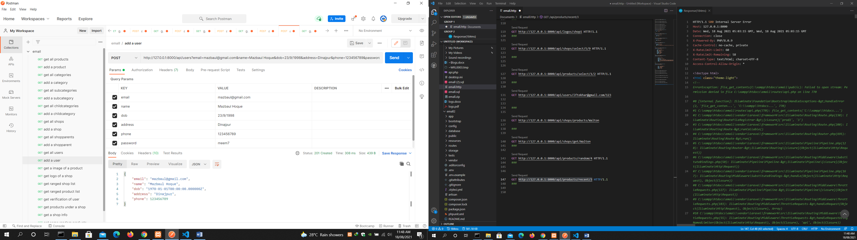

get an image of a product

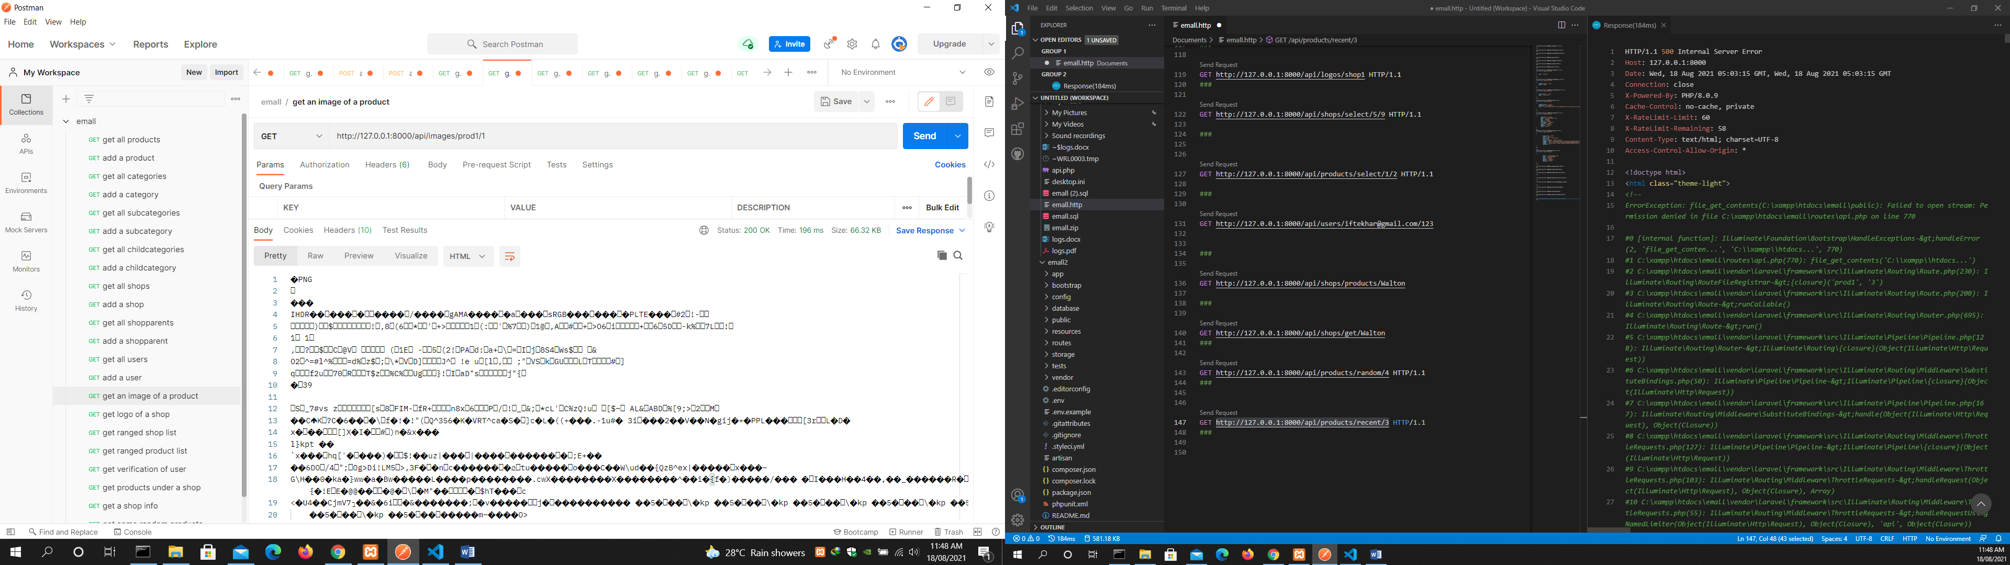

get logo of a shop

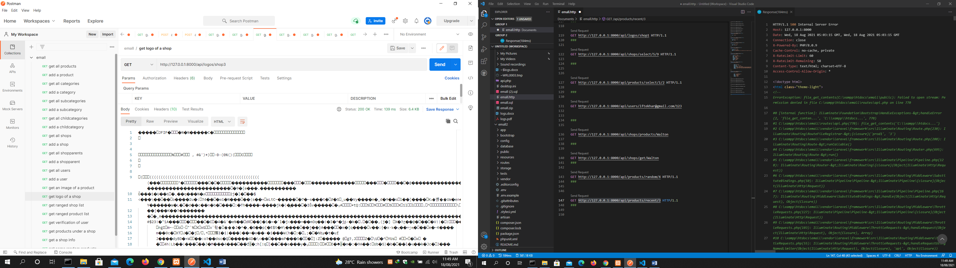

get ranged shop list

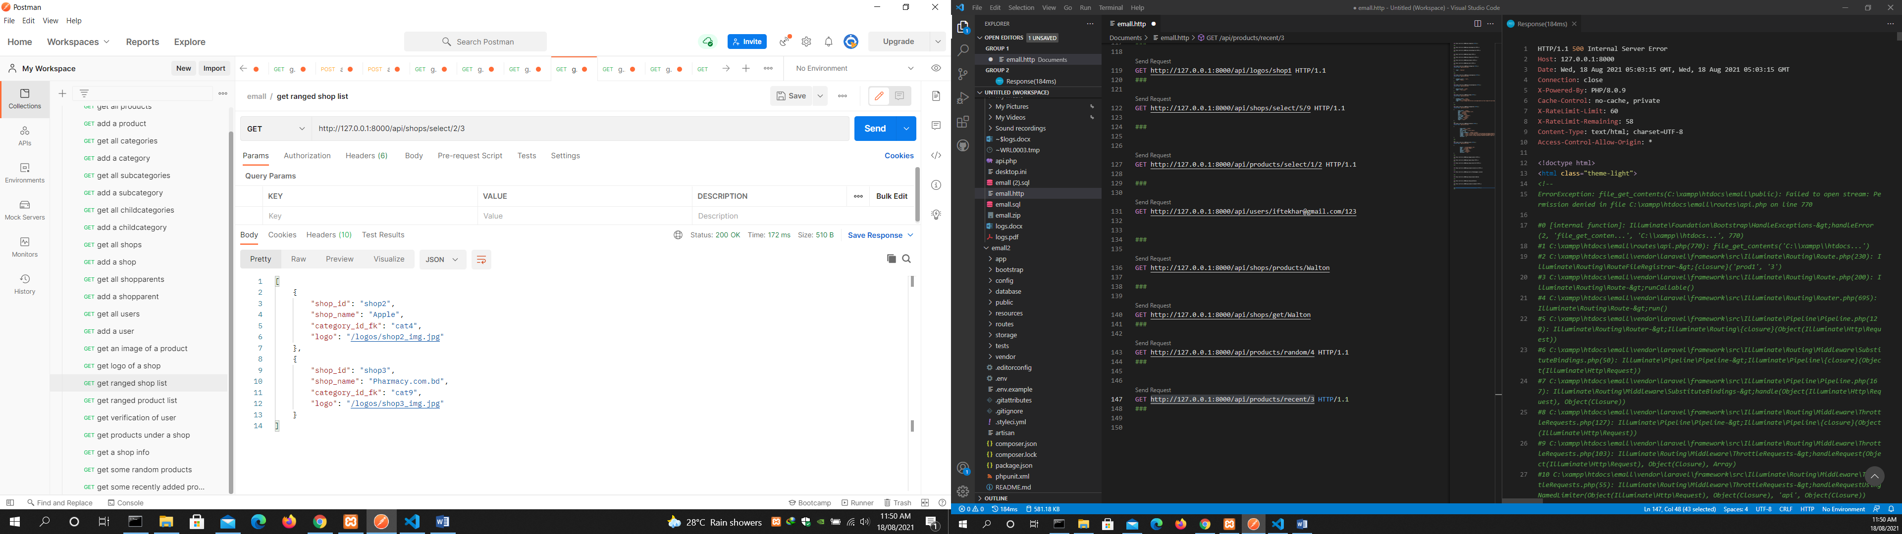

get ranged product list

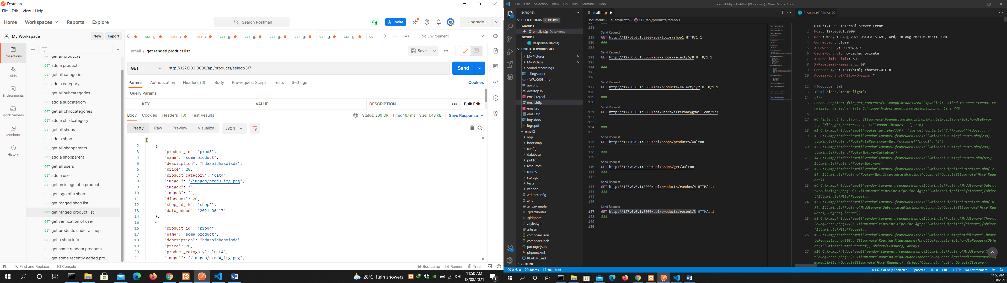

get verification of user

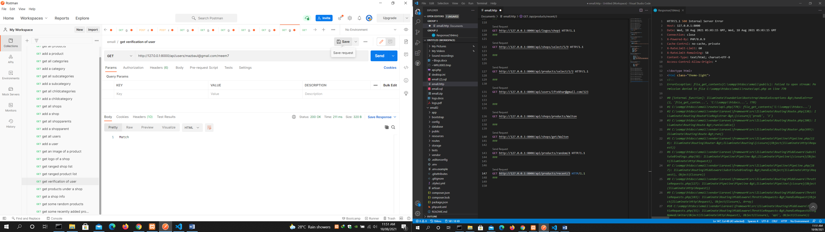

get products under a shop

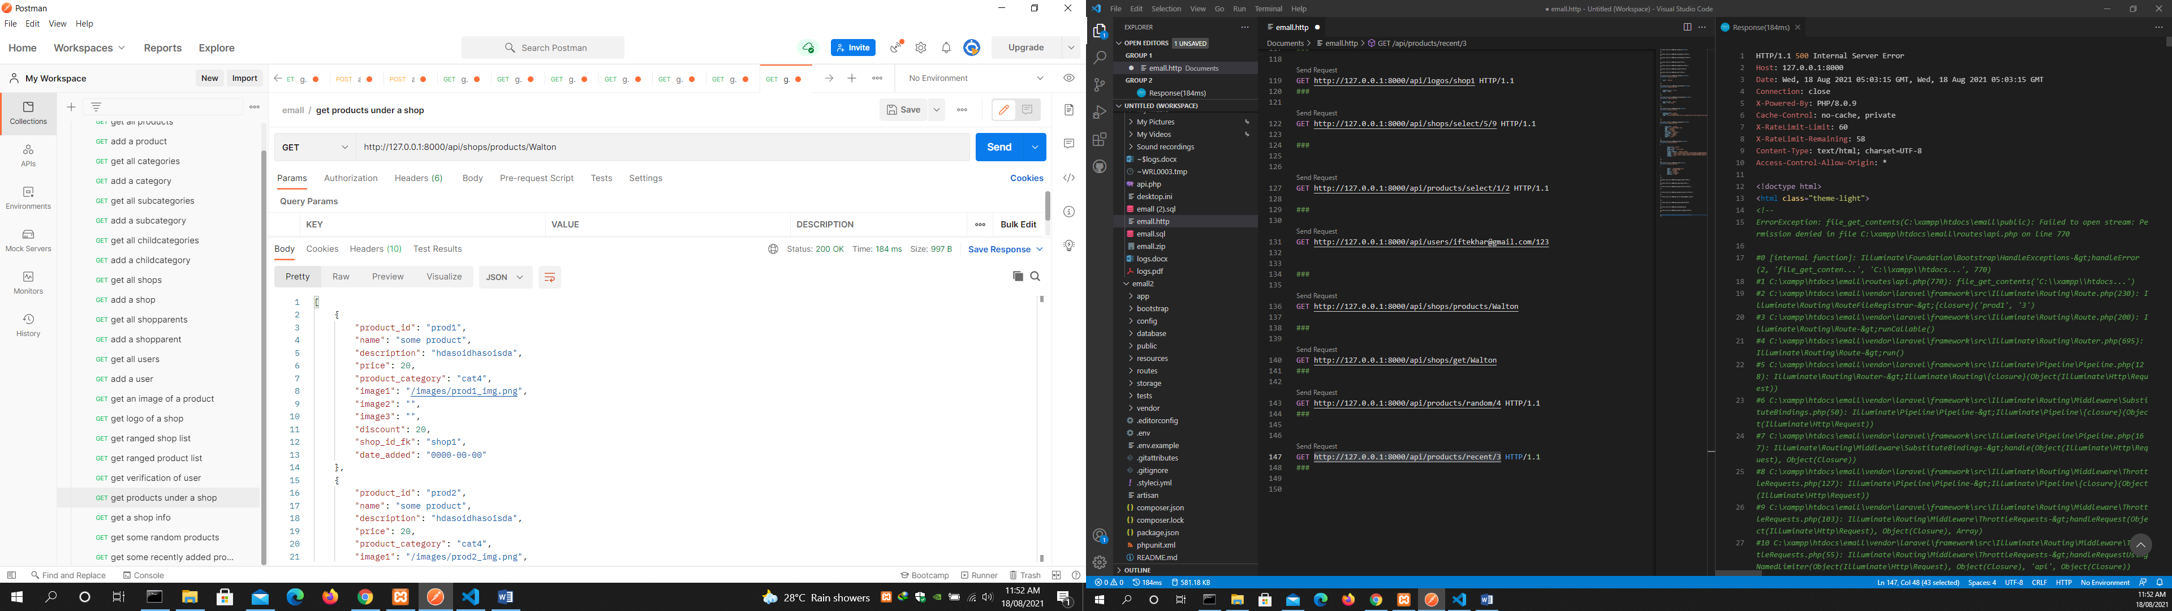

get a shop info

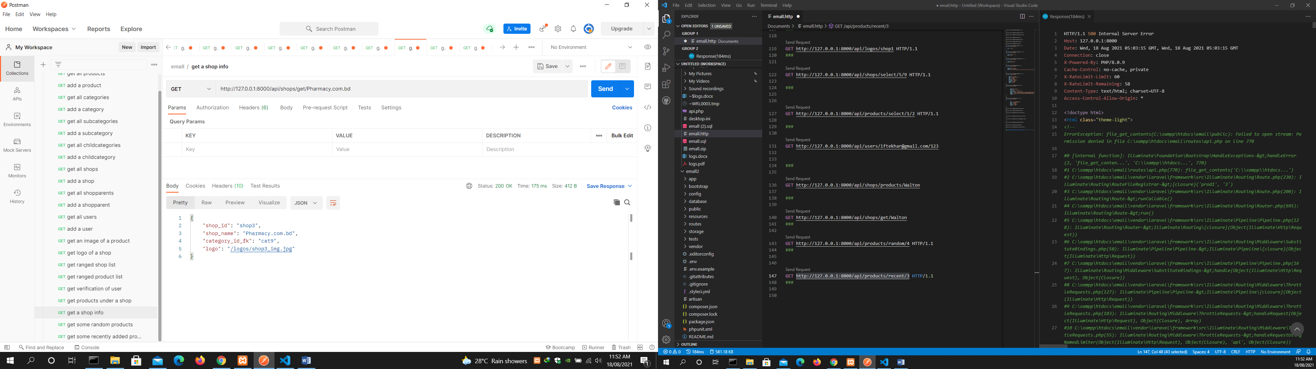

get some random products

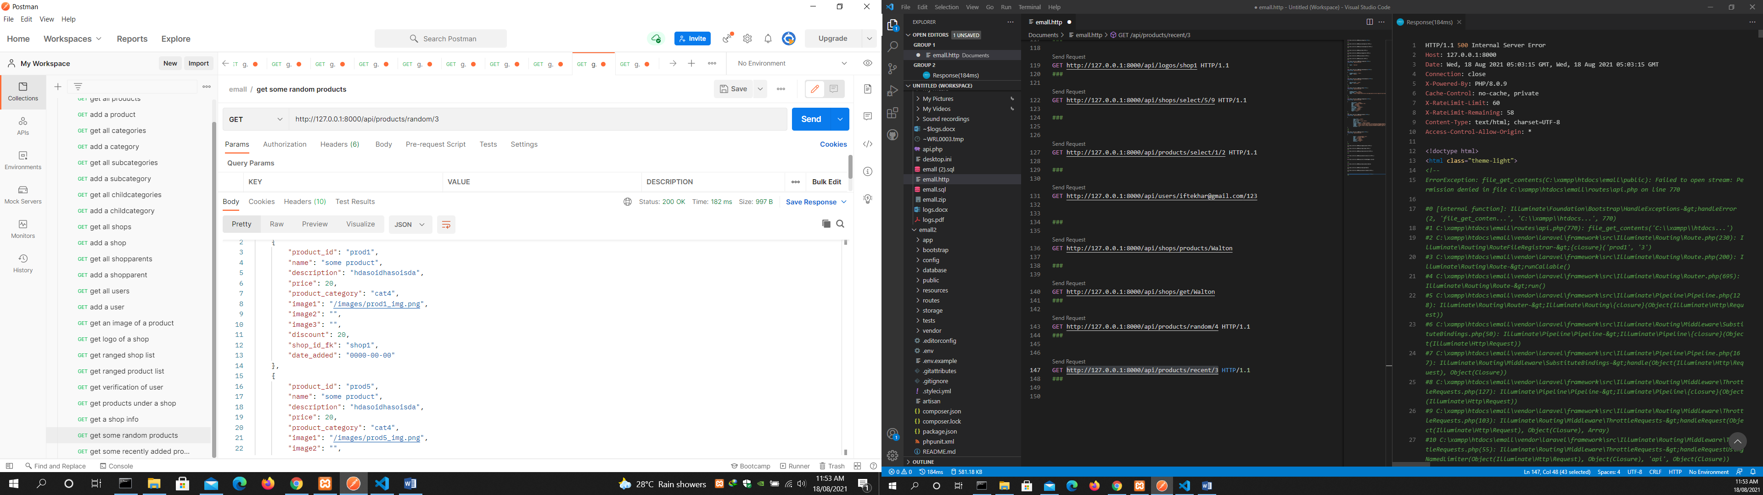

get some recently added products

